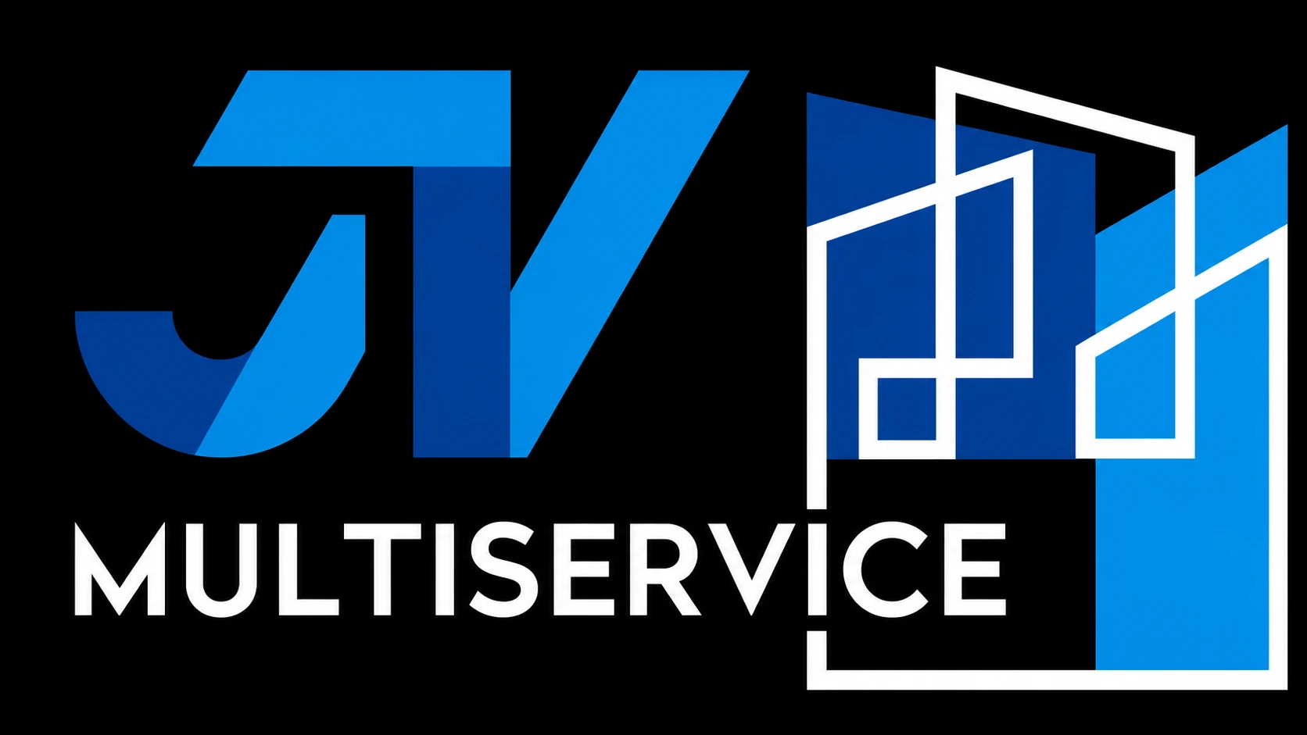
JV MULTISERVICE 2.0 INC.

Introduction to hotel and commercial property services
Dear Property Management Team,
We are JV Multiservice 2.0 Inc., specialists in renovation and maintenance for hotels and commercial properties in Miami. We would welcome the opportunity to understand your property’s needs and discuss how we can support your upcoming work.
We coordinate phases, schedules and access with management, taking hotel operations and guest circulation into account. Protecting work areas, keeping them clean during the work and conducting a final walkthrough are part of our approach.
Depending on the property’s conditions, we can review work involving:
• Painting, wallpaper and finishes; LVT flooring, carpet, tile and baseboards.
• Carpentry and fixed furniture; closets, cabinets, doors, frames and conventional hardware.
• Bathroom finishes and accessories; ceilings, drywall patching and surface repairs.
• Furniture and decor assembly; pressure washing, exterior surface improvements and basic landscaping.
We review each scope before quoting and agree on the execution requirements and the parties responsible for each item.
Please contact us to arrange a site visit or share your scope of work. Our website includes our services, introduction materials and contact options.
Kind regards,
Erick Jimenez
786-212-6697 | erickjimenez@jvmultiservice.net
Miami, Florida | jvmultiservice.net
Scan to learn about JV


